SUPPORTED DECISION-MAKING

A Resource Guide to Less-Restrictive Options

Supported Decision-Making and other less-restrictive options are part of an important movement to protect people’s rights and help them live better lives. Learn more inside!
We all need help in life sometimes, especially to make
certain decisions. Asking people for help to make
decisions when we need it is what
Supported Decision-Making is all
about. If we have a disability, though,
sometimes people think we need a
legal guardian to make decisions for
us, which removes our right to make
decisions about our life. There are
many ways we can learn and practice
decision making skills before
considering guardianship. This
Resource Guide will introduce some
of the ways we can get help without
giving up our right to make our own decisions.

The guide is broken up into different areas of life that we all experience. In each area, you can click on the arrow next to a word or phrase to learn more about how to use each kind of support.
If you are connected to the internet while you go through this guide, you will be able to watch some videos and click on links to more information on certain subjects, too.

Here’s your table of contents for what’s inside. Click a word or phrase below (you might have to hold the CTRL button at the same time) to go to that section of the guide.
MONEY & BENEFITS
HEALTH

RELATIONSHIPS
EVERYDAY LIFE

SAFETY

Payee
- A payee is a person or organization assigned by Social Security to manage a person’s benefit money. The payee can help us create a budget and make sure that bills and important living expenses get paid. After all the budgeted expenses are handled, we have access to money that’s left over for other things we want. A good payee will also involve us in our budgeting so we know where our money is going, and so we can learn about managing their money. Visit the links below to learn more Payees:
  - Social Security – Representative Payee
  - FAQ for Representative Payees (including how to apply to become payee)

Power of Attorney (Financial)
- We can decide we want someone else, called an “agent”, to make certain financial decisions for us, by documenting this on Power of Attorney form and having it notarized (or signed by two witnesses). We can give the agent a lot of authority, or we can limit that authority to specific kinds of actions and decisions. To use a Power of Attorney, also called a POA, we have to understand that we’re giving permission to someone else to make decisions on our behalf. We can cancel or modify the Power of Attorney later on, as long as we still understand what we’re doing at the time. Here are some forms to use for Financial Power of Attorney:
  - Limited Power of Attorney
  - Durable Power of Attorney

Joint Bank Account
- A bank account can be set up so that more than one person has access to and authority over it, or so that certain limits apply to it. This can help us transition into learning how to manage our own money, and it allows for opportunities to make financial decisions together with someone else while we are learning. Check with your local bank for details about joint accounts.

(Special Needs) Trust Fund
- Trust funds can be set up to hold and manage large amounts of money and some property without affecting our eligibility for benefits like Social Security, Medicaid or a Waiver, or Housing Assistance. A trustee manages the money and uses it to pay for things that our benefits do not cover. There are different kinds of trust fund, but one of the most popular for people who receive Medicaid and/or Social Security benefits is a Special Needs Trust Fund. You can learn more about trust funds by visiting these links:
  - Disability Benefits 101 – Trust Funds
  - STABLE Accounts
  - DD Council – Estate and Future Planning
  - 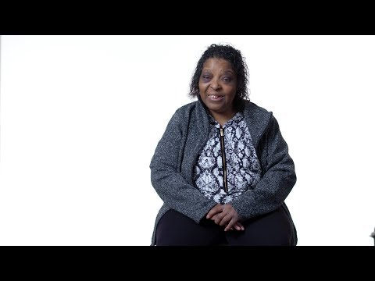

Technology & Apps
- There are many ways to use technology to help us manage our money, from online banking and autopay for bills, to budgeting apps or reminders we can set on our phone or tablet. New technology becomes available all the time, so begin exploring what’s out there!
  - Atvisor
  - Disability Cocoon

Benefits Analysis & Planning
- Working and earning money can create a lot of opportunities for us, like having money to buy and do things we want. If we work and receive benefits, we might have questions about how those two things affect one another. Maybe we are afraid we’ll lose our benefits if we work, or we want to learn about other programs that help us work and save money. We can meet with someone to help us understand what our options are. They can give us important information so we can make informed decisions about working. Here is a great place to start:
  - Employment First – Benefit Planning Information

Supported Decision-Making
- Supported Decision-Making means getting help to understand information so that we can make our own decisions. We reach out to people we trust to help us, but we get to make the final decision. When it comes to money and benefits, we might want to talk to someone about a big purchase, about prioritizing what we buy, or about ways to earn or save more money. Sometimes people document Supported Decision-Making Agreements on forms, like this:
  - ACLU Supported Decision-Making Agreement
  - Cents and Sensibility – A Guide to Money Management for People with Disabilities

Financial Planning & Counseling
- There are experts and professionals who can help us learn about managing or saving our money, or get better at those things. Some nonprofits provide free financial counseling, so see what’s available in your area. Special Needs Planners may be attorneys or bank employees who can give us advice about how to plan for our future. Find one here:
  - Special Needs Answers – Find a Planner

Authorized Representative
- If we have Medicaid, we can choose someone to act in our place when it comes to those benefits. This person is called an Authorized Representative, and they can receive copies of everything that Medicaid sends to us. An Authorized Representative has to keep our information confidential, but we can decide what authority they have over our Medicaid. We can have our Authorized Representative do things like talk to caseworkers and speak on our behalf, or represent us at hearings. They can also be responsible for getting important information or paperwork to our local Medicaid office so our benefits can continue. Here’s the form to complete to designate someone as our Authorized Representative:
  - Designation of Authorized Representative

Release of Information
- When we sign a release of information (HIPAA), we are giving permission to doctors and other professionals to share important health and medical information about us with other people. We can decide who these other people are, and we can decide what information gets shared with them. If we choose to have information shared with people we trust, it might be easier for them to help us make decisions about our health.

Supported Decision-Making
- Making decisions about our health can be hard sometimes. What our doctor tells us might be confusing. While we can always ask the doctor to explain it in a way we can understand, we can also ask other people we trust to help us understand things better so we can make an informed decision. Maybe we know someone who has taken the same medication, or who has had the same condition or surgery. We can ask them about their experience or for advice. Or maybe we need someone who really understands us to communicate with our doctor or another professional for us. All of these things can be done as part of Supported Decision-Making! Here are some places to learn more about Supported Decision-Making and Healthcare:
  - Supported Decision-Making in Healthcare and Medical Treatment Decisions
  - 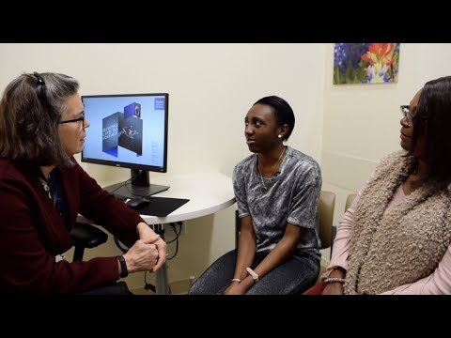
  - ACLU Supported Decision-Making Agreement

Technology & Apps
- When it comes to our health, there are all kinds of technologies we can use to help us stay on top of things. Pill reminders and medication dispensers can help us remember to take our medication, or we can use alarms and calendars in our phones or tablets to remind us of important things. Some doctors offer virtual check-ups or check-ins, too. Whatever it is you need, it’s probably out there! Here are some resources to help you find it:
  - Atvisor
  - Disability Cocoon
  - Lending Library

Power of Attorney (Healthcare)
- We can decide we want someone else, called an “agent”, to make certain healthcare decisions for us, by documenting this on Power of Attorney form and having it notarized (or signed by two witnesses). We can give the agent a lot of authority, or we can limit that authority to specific kinds of actions and decisions. To use a Power of Attorney, also called a POA, we have to understand that we’re giving permission to someone else to make decisions on our behalf. We can cancel or modify the Power of Attorney later on, as long as we still understand what we’re doing at the time.
  - Disability Rights Ohio – Creating a Durable POA for Healthcare
  - Ohio Healthcare Power of Attorney

Advance Directive/Living Will
- We might have strong feelings about what kind of medical treatment we want or do not want in the future, especially if our life depends on it (i.e.: life support). When this is the case, we can create an Advance Directive or Living Will where we document what we want to happen. This way doctors and other medical professionals can follow our wishes even if we are not able to express them at the time. We might also want someone else to make decisions about our healthcare and medical treatment in the future if we are not able to. In these cases, we can use a Power of Attorney as stated above.
  - Ohio Living Will Declaration

Counseling
- It’s not always easy to know what to do in our relationships, whether they’re work relationships, family relationships, friendships, romantic relationships, or something else. Sometimes it’s helpful to talk to someone like a counselor who can help us understand our thoughts and feelings, figure out how we want to be treated in different relationships, and learn how to treat other people with respect. When relationships of any kind change or end, or when we lose people in our lives it can be scary, stressful, and feel overwhelming. We might feel better if we can talk about it with someone else. This doesn’t always have to be a counselor, but counselors are professionals who usually know how to help us when we are grieving.
  - 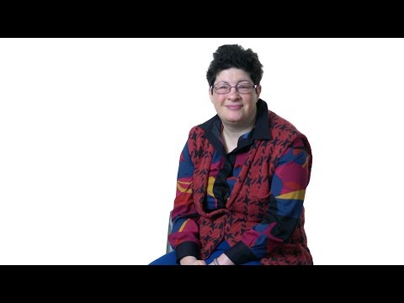

Supported Decision-Making
- Supported Decision-Making can help us make decisions about our relationships, too. We can reach out to people we know and ask them for advice. Maybe we know someone who has been in a similar situation, and they can tell us how they handled it. Or we can get help to practice having a conversation with a friend or romantic partner. Sometimes we even weigh the pros and cons of being in a relationship to help us decide what to do. If we want to get to know more people or make more friends, sometimes someone we already know can help introduce us to new people. Here are some resources that can help us learn what we want in our relationships:
  - Healthy Relationships
  - ACLU Supported Decision-Making Agreement
  - 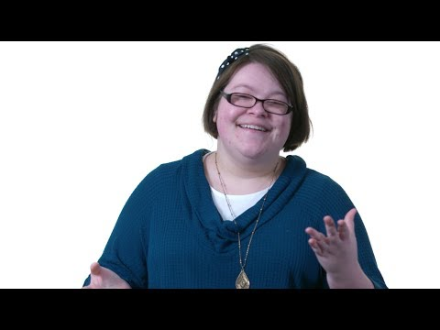

Chosen Representative
- If you receive services in the Developmental Disabilities System and you’re not comfortable making decisions about your services by yourself, you can ask someone ese to do that for you. This person will be your Chosen Representative. They have to be an adult and they can’t benefit financially from the decisions they make for you. You have to put this agreement in writing.
  - Chosen Representative Form

Technology & Equipment
- Technology is a part of everyday life for most of us! If you need assistance with something, from cooking and cleaning to eating and getting dressed, or communicating with other people, there’s probably technology out there to help! Maybe an app or reminder on your phone can help you remember important things, or a device turns your stove off if you forget to, or an in-home assistant can turn your lights off and on or adjust the thermostat for you. You can even learn how to fix something around the house by watching a video online. Here are some places that are designed to help you find the technology you need and answer any questions you might have, even if you’re not “tech savvy”:
  - Atvisor
  - Disability Cocoon
  - Lending Library
  - Ohio Developmental Disabilities Council – Technology Lending Programs Guide
  - Lending Library Map
  - iPhone Accessibility

Supported Decision-Making
- We all need help to make some decisions sometimes. We might ask people we trust for advice or talk to experts to get their opinions or to understand our options. Other times it might help us to role-play a situation or make a pros and cons list. Even though we are asking for help, we still make the final decision. And the more help we get to practice making our own decisions, the better we get at it over time! Sometimes we put a Supported Decision-Making agreement in writing so everyone knows what to do. Supported Decision-Making is a movement happening all over the world, so give it a try!
  - 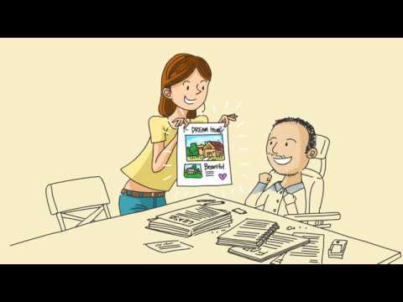
  - ACLU Supported Decision-Making Agreement
  - An Introduction to Supported Decision-Making
  - Example: Jamal Feeling Safe, and Supported Decision-Making
  - Decision-Making Profile

Conservator
- Sometimes we are mentally able to review information and make decisions, but physically we’re unable to – maybe because we’re sick or because in our older age some things just don’t work as well as they used to. When this is the case, we can choose a Conservator to act on our behalf. We have to ask Probate Court to approve and supervise this arrangement, but we get to decide who the person is, what they help us with, and how long the arrangement should last. It’s kind of like a voluntary guardianship. Here’s just one example of someone who could use a conservator:
  - What is a conservatorship?

Future Planning
- It’s important to think about our future so we can make a plan to live the kind of life we want. Things won’t always go our way, but if we don’t have a plan it can feel like things are just happening to us and that we don’t have any control over our life. By thinking and talking about what we want our future to look like, big and little decisions we’ll need to make, and what we will need to do to accomplish our goals we can create a plan that helps us stay on track. Future planning doesn’t just happen once – we can update and change our plan throughout life. The resource below is a great place to start!:
  - The ARC – Build Your Future Plan

Supported Decision-Making
- A life worth living usually involves taking some risks, but how do we decide when to take a risk and when to play it safe? Or maybe we need help to stay safe or help to understand why something is dangerous. When we use Supported Decision-Making, we reach out to people around us for help to understand information or situations so we can make a decision which is best for us. These people can help us understand what might happen if we make certain choices, role-play potentially dangerous situations and how to respond to them, help us make a pros and cons list, or use tools like the Happy & Safe Gride (below) to help us understand our options and make a decision so we can be both happy and safe.
  - 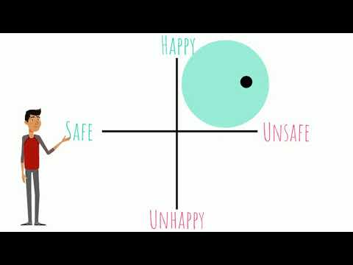
  - ACLU Supported Decision-Making Agreement

Protection Order
- We all have the right to feel safe. If someone is hurting or threatening us, we can ask the court to order them to stay away from us. This can sometimes be hard if the person who is treating us badly is someone we know, but remember that no one should feel unsafe. You can learn more about Protection Orders here:
  - Understanding Protection Orders

Technology & Apps
- From security systems to fingerprint door locks, remote supports and emergency response pendants to water temperature controls and virtual in-home assistants, there is a bunch of technology nowadays that can help us stay safe and get help in an emergency when we need it. There are also places out there to help us find what we need. Explore the resources below for more information:

  - 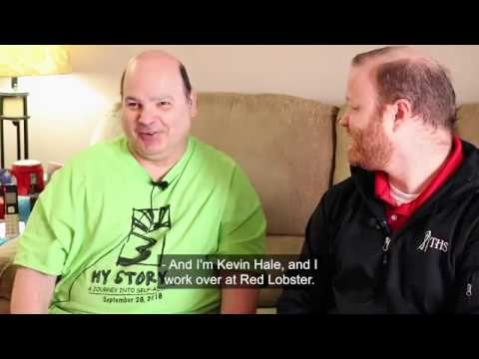
  - Atvisor
  - Disability Cocoon
  - Lending Library

Safety Plan
- Sometimes talking about unsafe situations and how we might respond to them can help us feel more prepared and develop our problem-solving skills. One of the tools we can use for this is a Safety Plan. We might never have to use it, but thinking about how to stay safe can come in handy if we find ourselves in a dangerous situation later on. Here are some resources to help us create our own Safety Plan:
  - Adult Advocacy Centers
  - Safety Planning Guidebook – Self-Directed
  - Safety Planning Guidebook – Assisted

We hope you found the information in this guide helpful. The guide is a work in progress because new resources are created or found all the time! If you think we missed something that should be included in the next version, please let us know:
jyoung@ohinetworkforinnovation.com
Below are some additional resources you can explore, including some that we reviewed while putting together this guide:
- Adult Advocacy Centers - A Guide to Informed Consent for People with Disabilities
- Disability Rights Ohio - Guardianship: Frequently Asked Questions
- National Resource Center for Supported Decision-Making
- The ARC – Center for Future Planning

This guide was created by the Ohio Network for Innovation (ONI) as part of the Supported Decision-Making Project. Additional resources about Supported Decision-Making and other services offered by ONI can be found at www.ohionetworkforinnovation.com, and on our Facebook and YouTube pages.

