**How to View your PAWS**

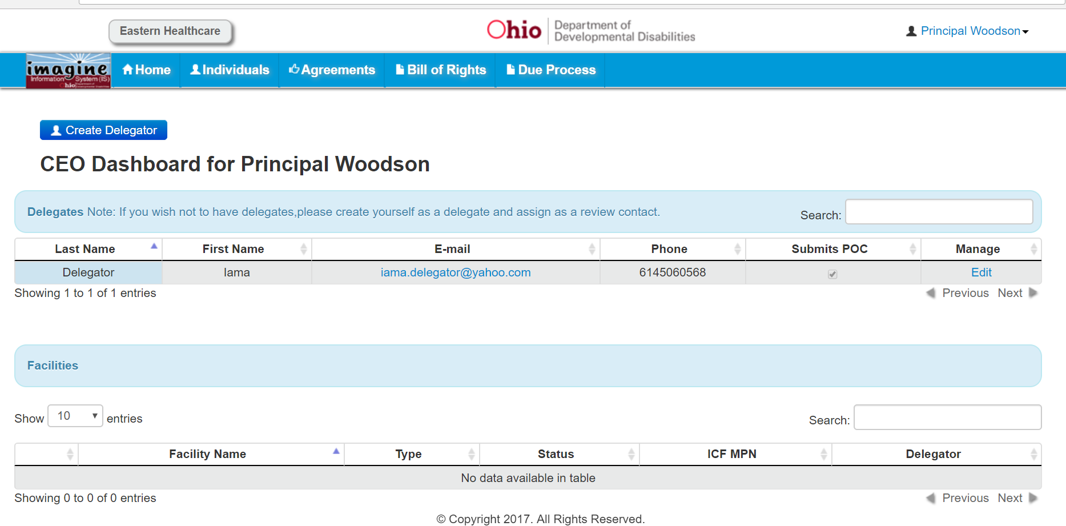

This is your home page. Click on “Individuals” to see those that you serve.

_____________________________________________________

Click on the Individual’s name in blue that you want to view.

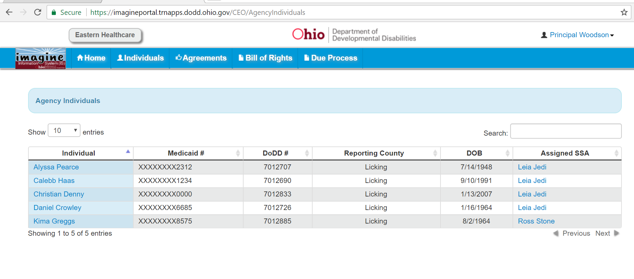

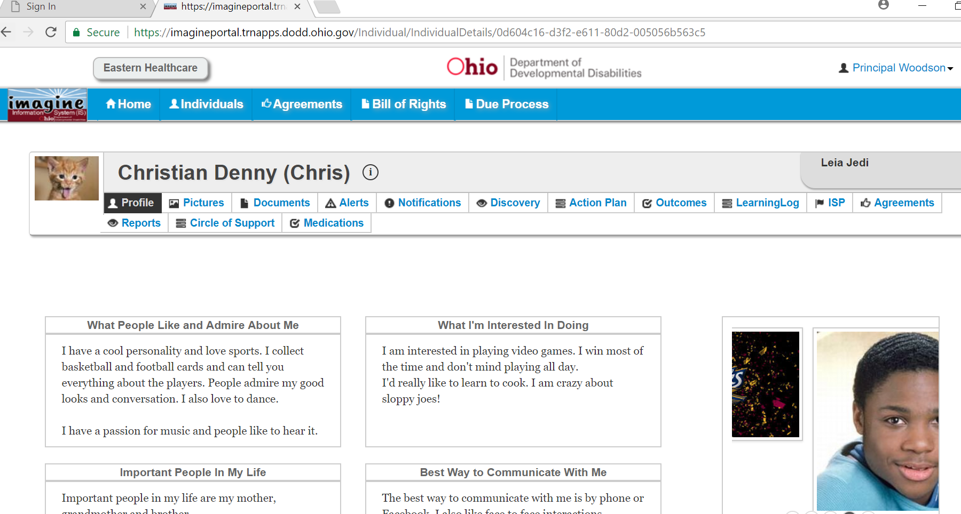

Click on “Reports.” This section takes a bit of time to load. Be patient.

Click on Download PAWS Detail Report

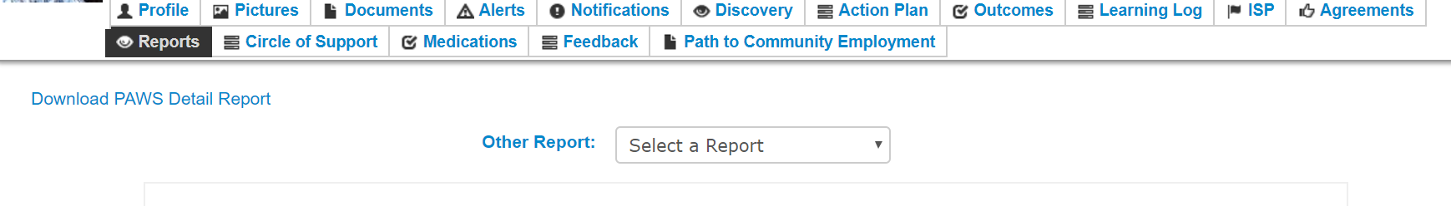

Scroll to the bottom and click on Service Summary. This will open the PAWS.

