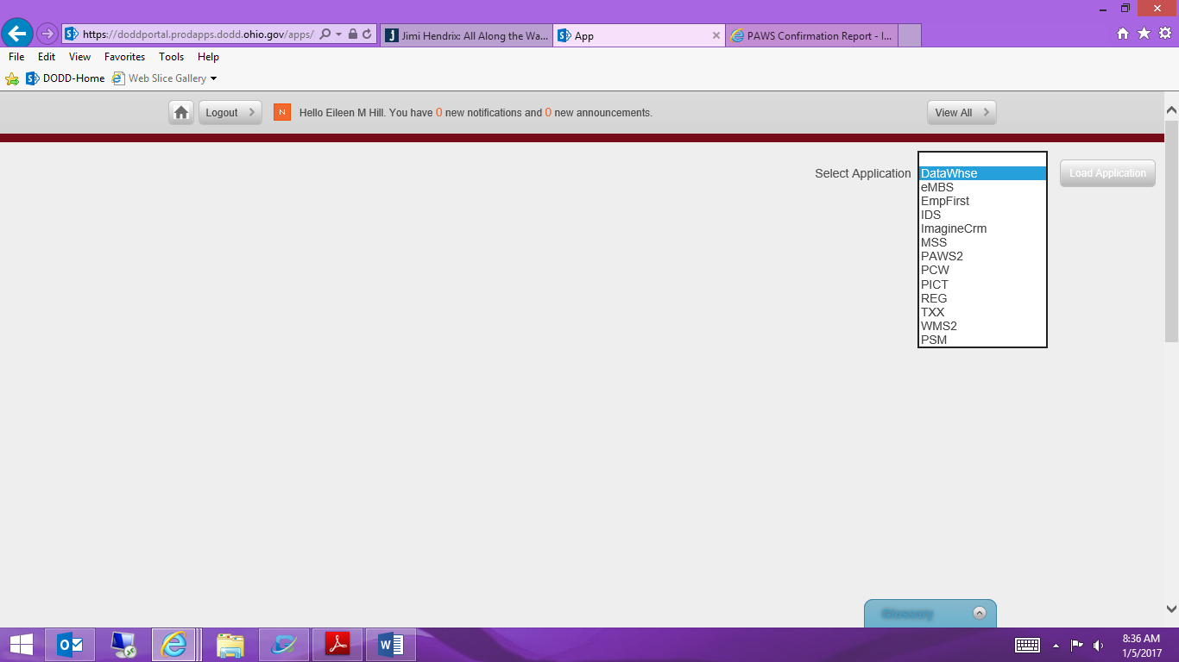

Once you have logged onto the state site you will go to applications and select DateWhse then click on load application

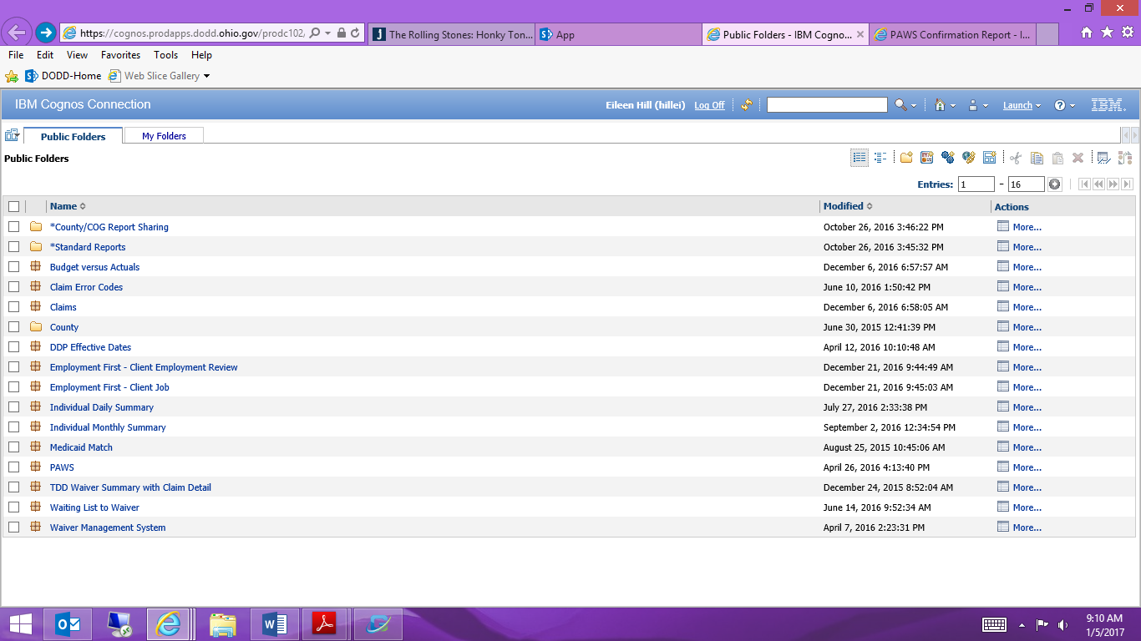

Click on Standard Reports

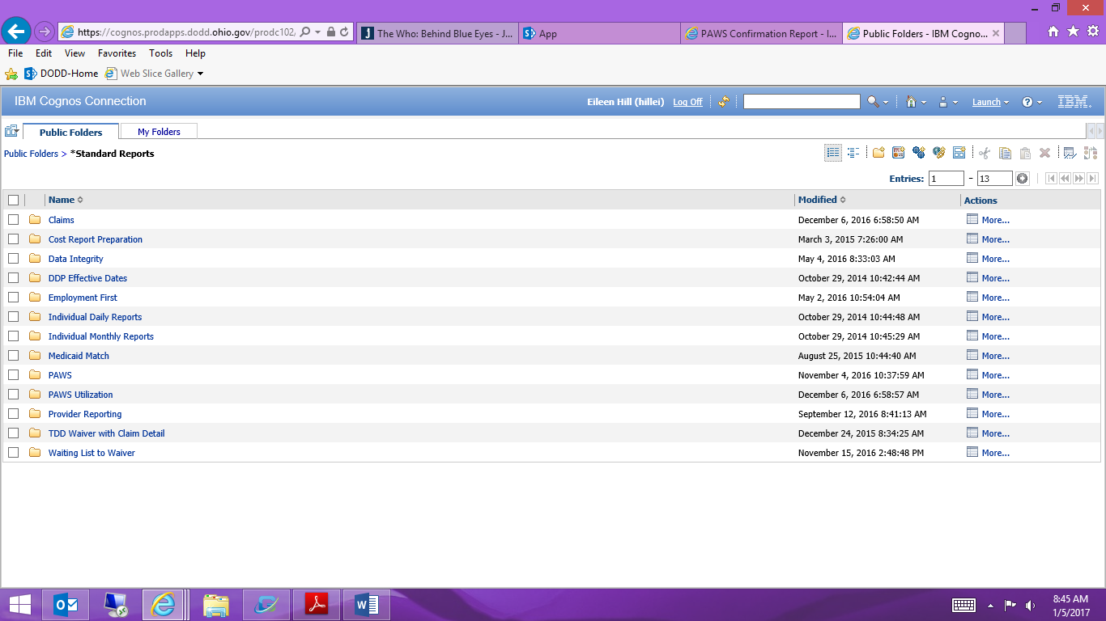

Click on Provider Reporting

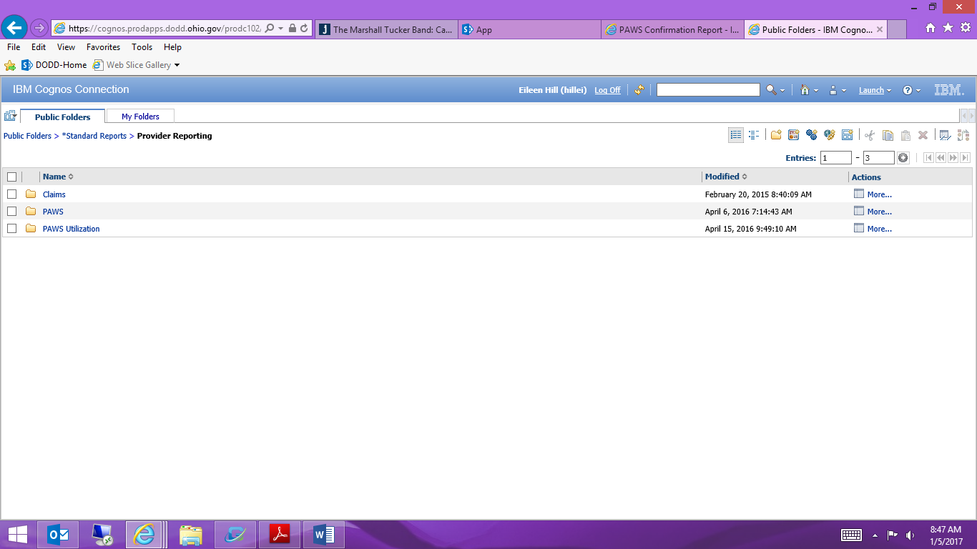

Click on PAWS Utilization

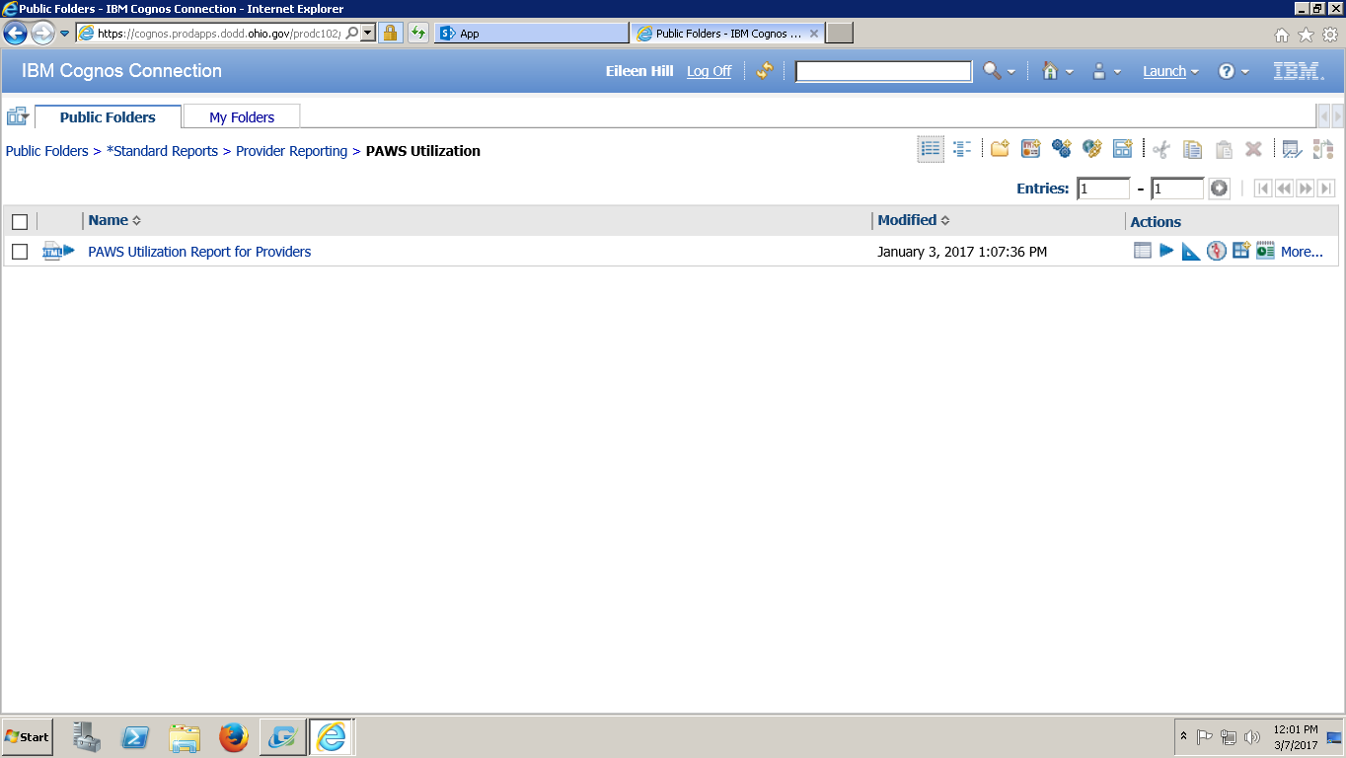

Click on PAWS Utilization Report

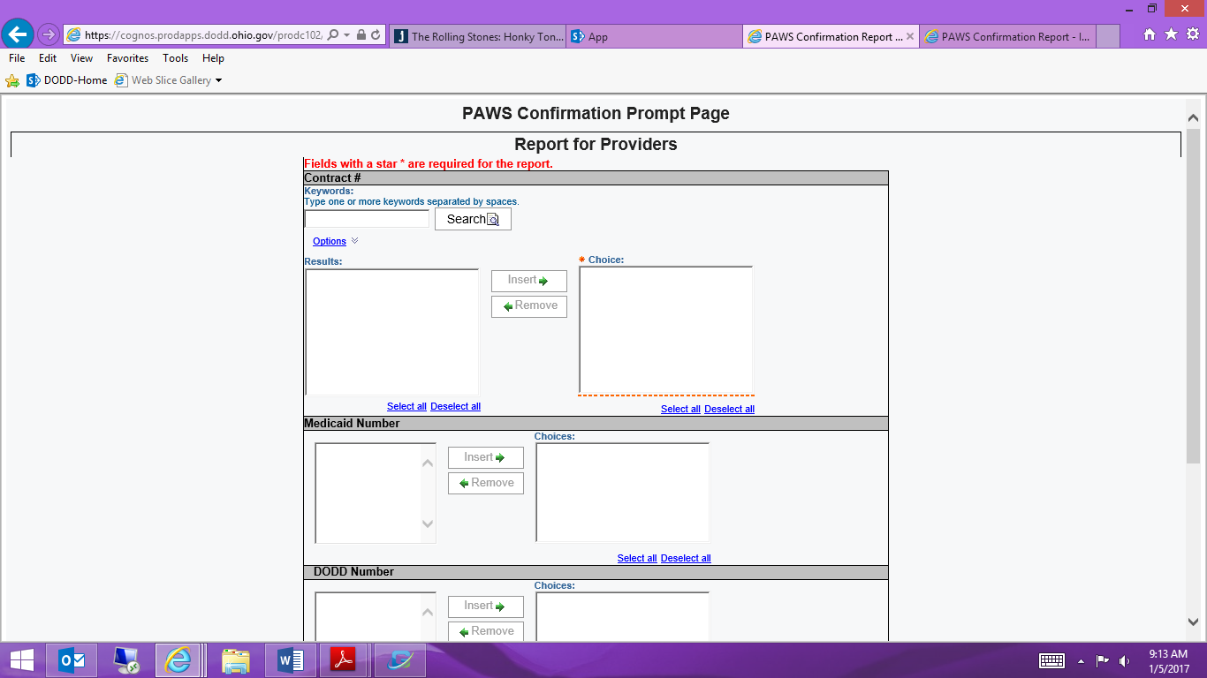

Enter your provider number and click on search. It will move your provider number into the result box. You will need to highlight your number in the result box and click on the insert button it will transfer your provider number to the choice box. The Choice box is the info that the report uses to run your requested data.

In the PAWS approval date enter one or two months prior to a redet/revision start date, leave the second date as the current date. Once you have the dates selected click on finish at the bottom of the screen and your PAWS should come up for the individual you had requested.

Enter your Individuals DODD number and click on search. It will move your Individuals DODD number into the result box. You will need to highlight the number in the result box and click on the insert button it will transfer the DODD number to the choice box. The Choice box is the info that the report uses to run your requested data.

Enter in the year in which you want to run your report on. Example: If the plan is 1/1/17 – 12/31/17 and you want to see the 1st part of the span you would enter 2017, if you want to the 2nd span it would be 2018

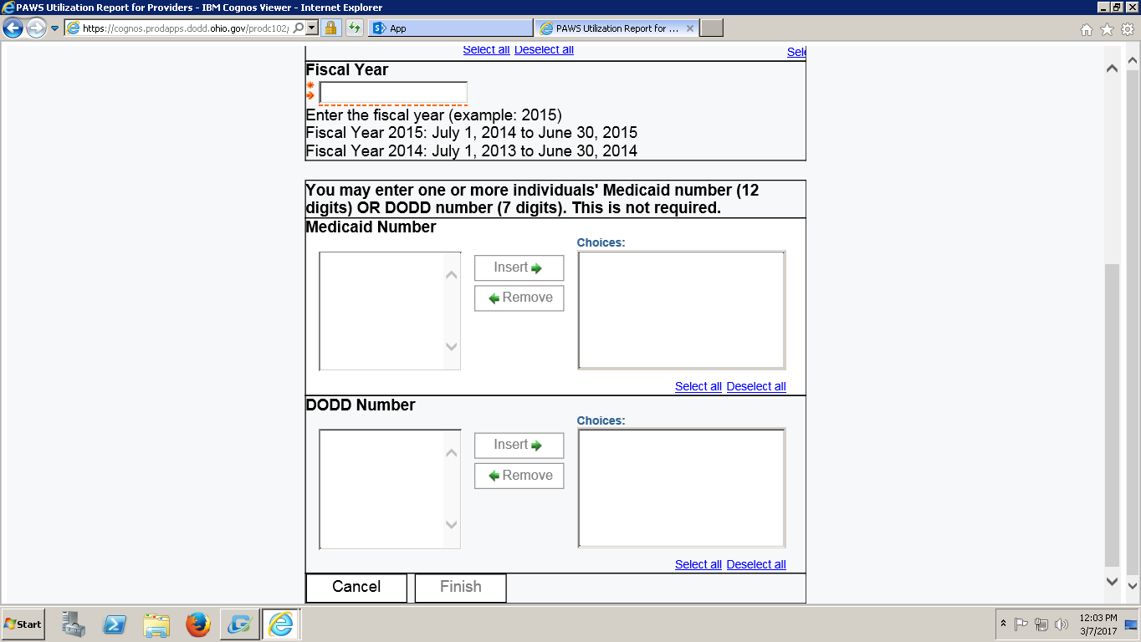

Enter in individual DODD number and insert in to the box on the right.