**How Providers Agree to the ISP**

From the Imagine Portal:

Click on Notification

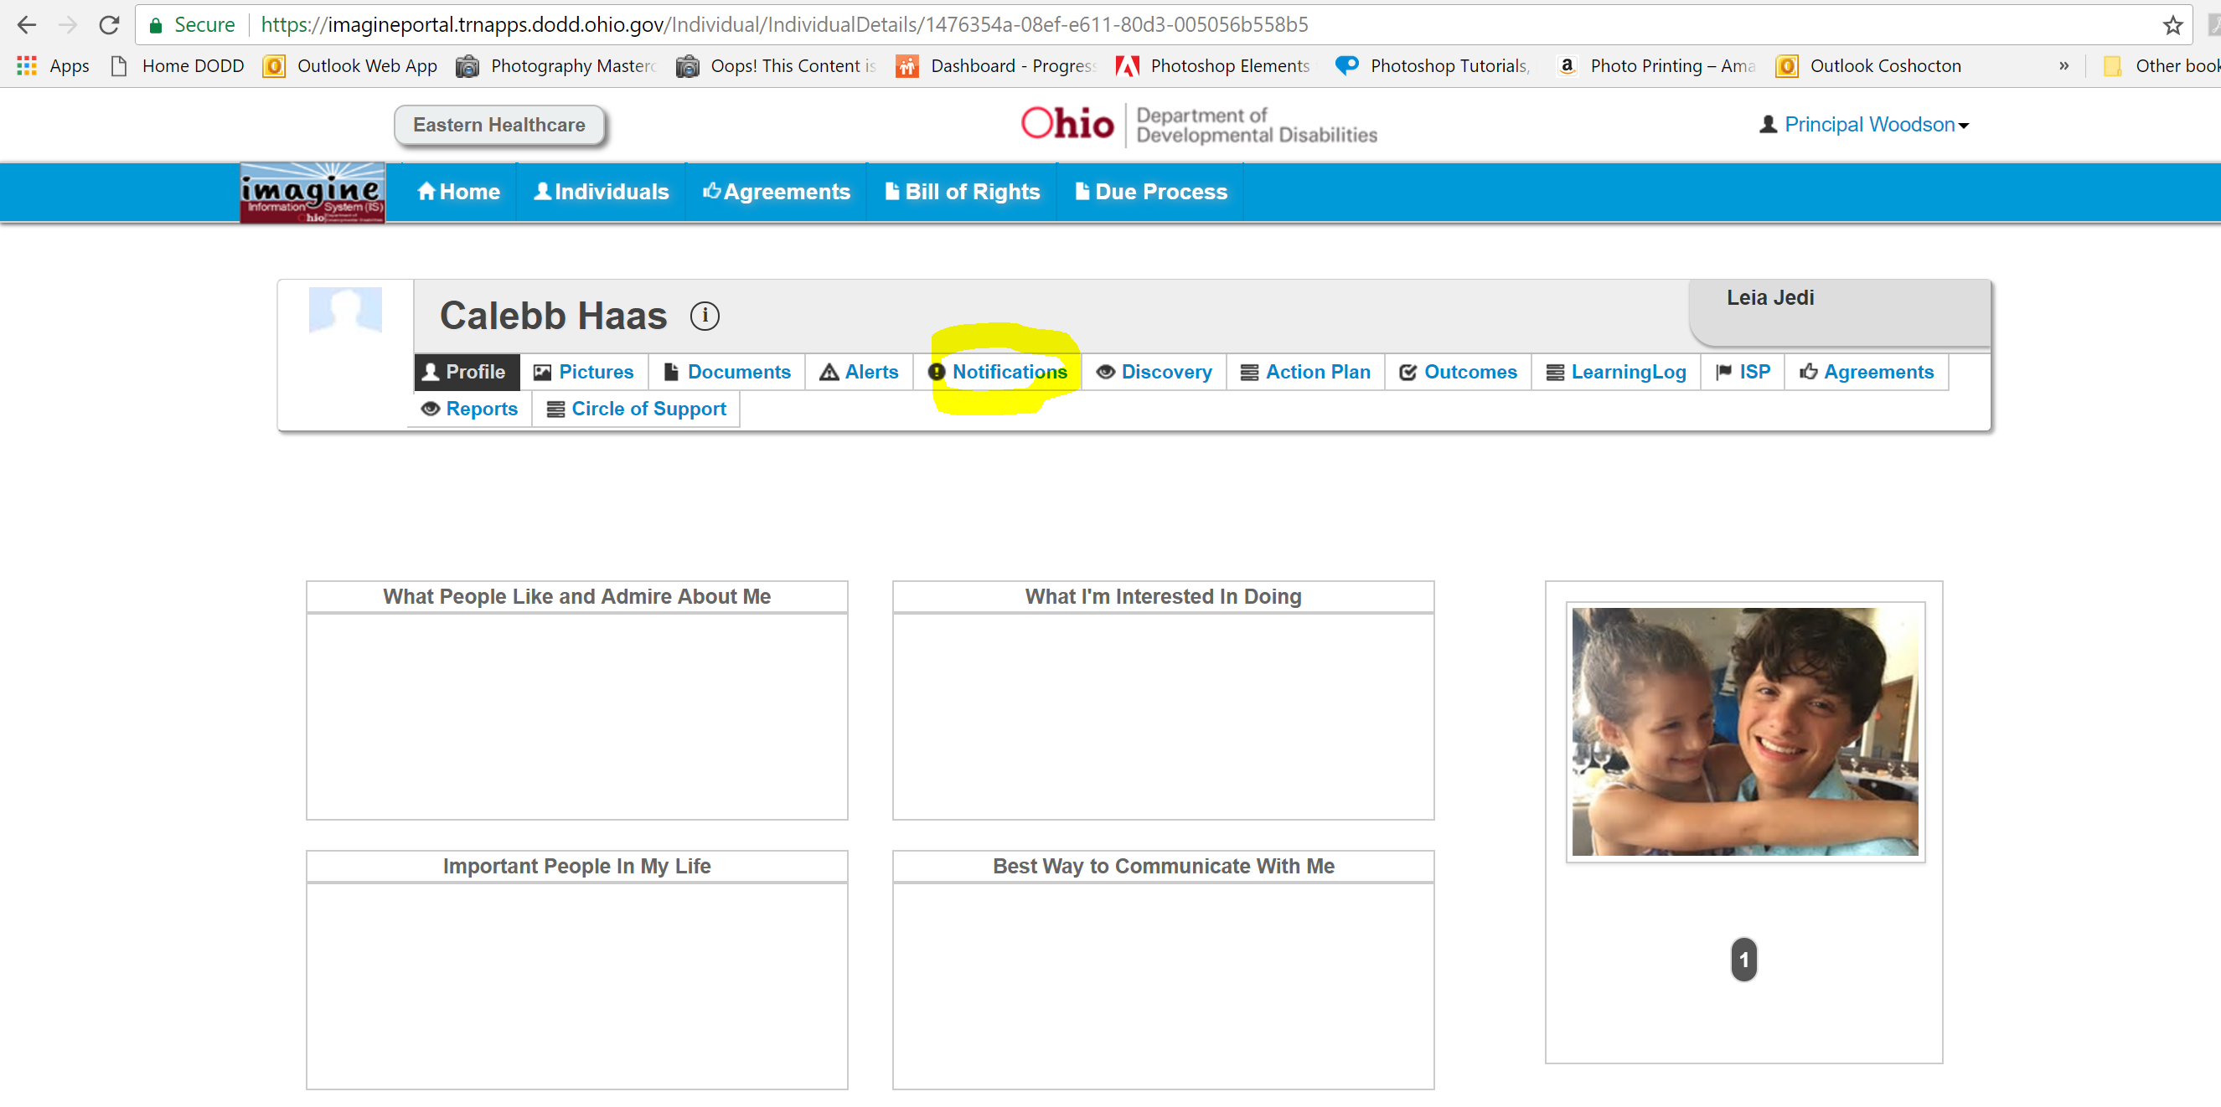

Click on ISP Agreement Requested

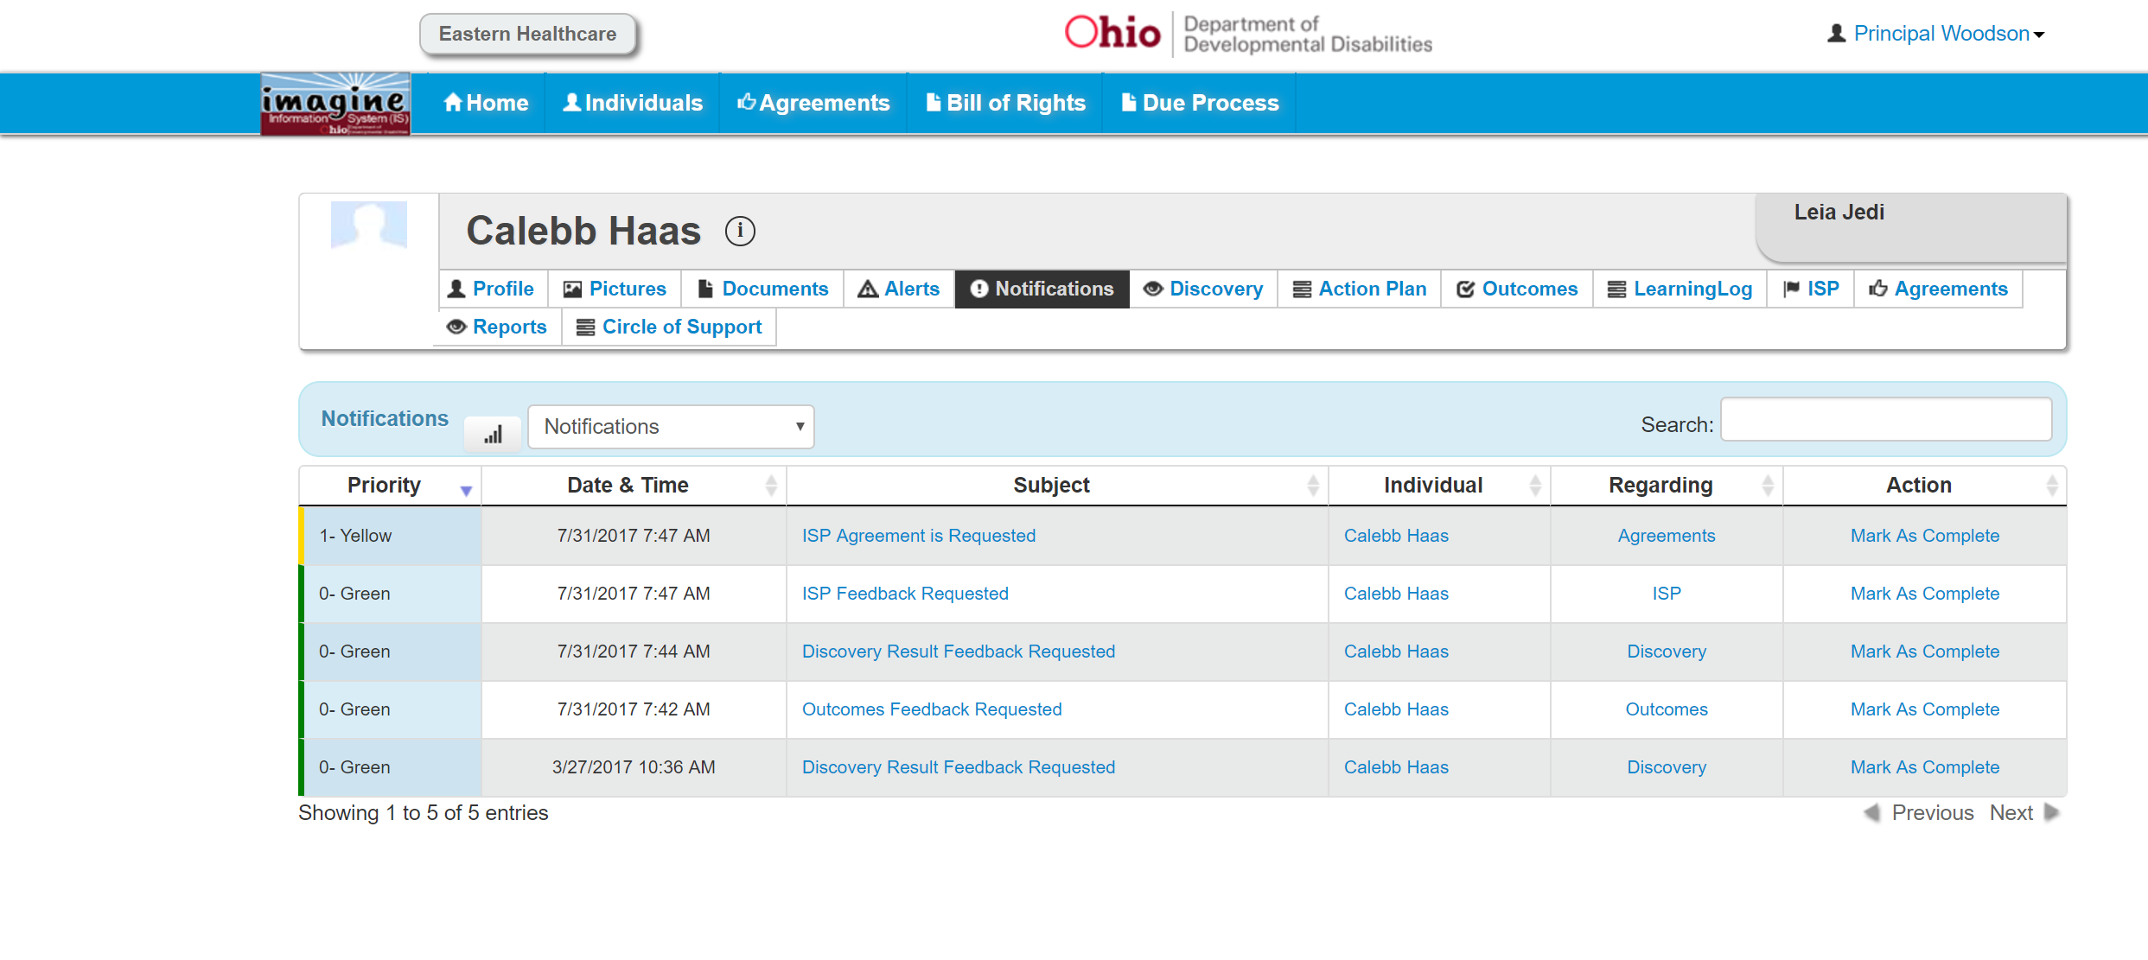

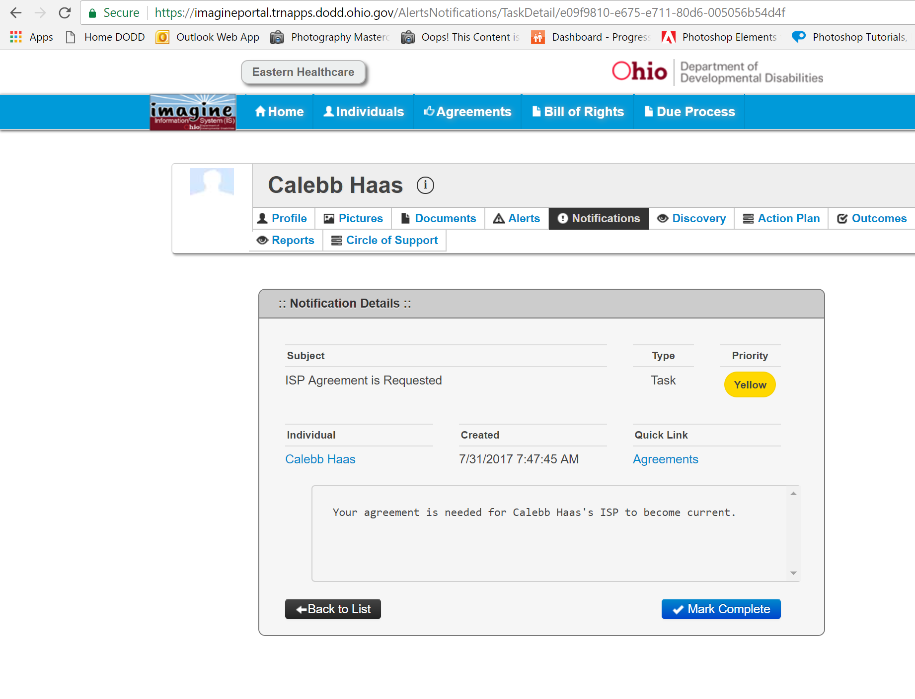

Click on “Agreements”

Click on the red “click to agree” button

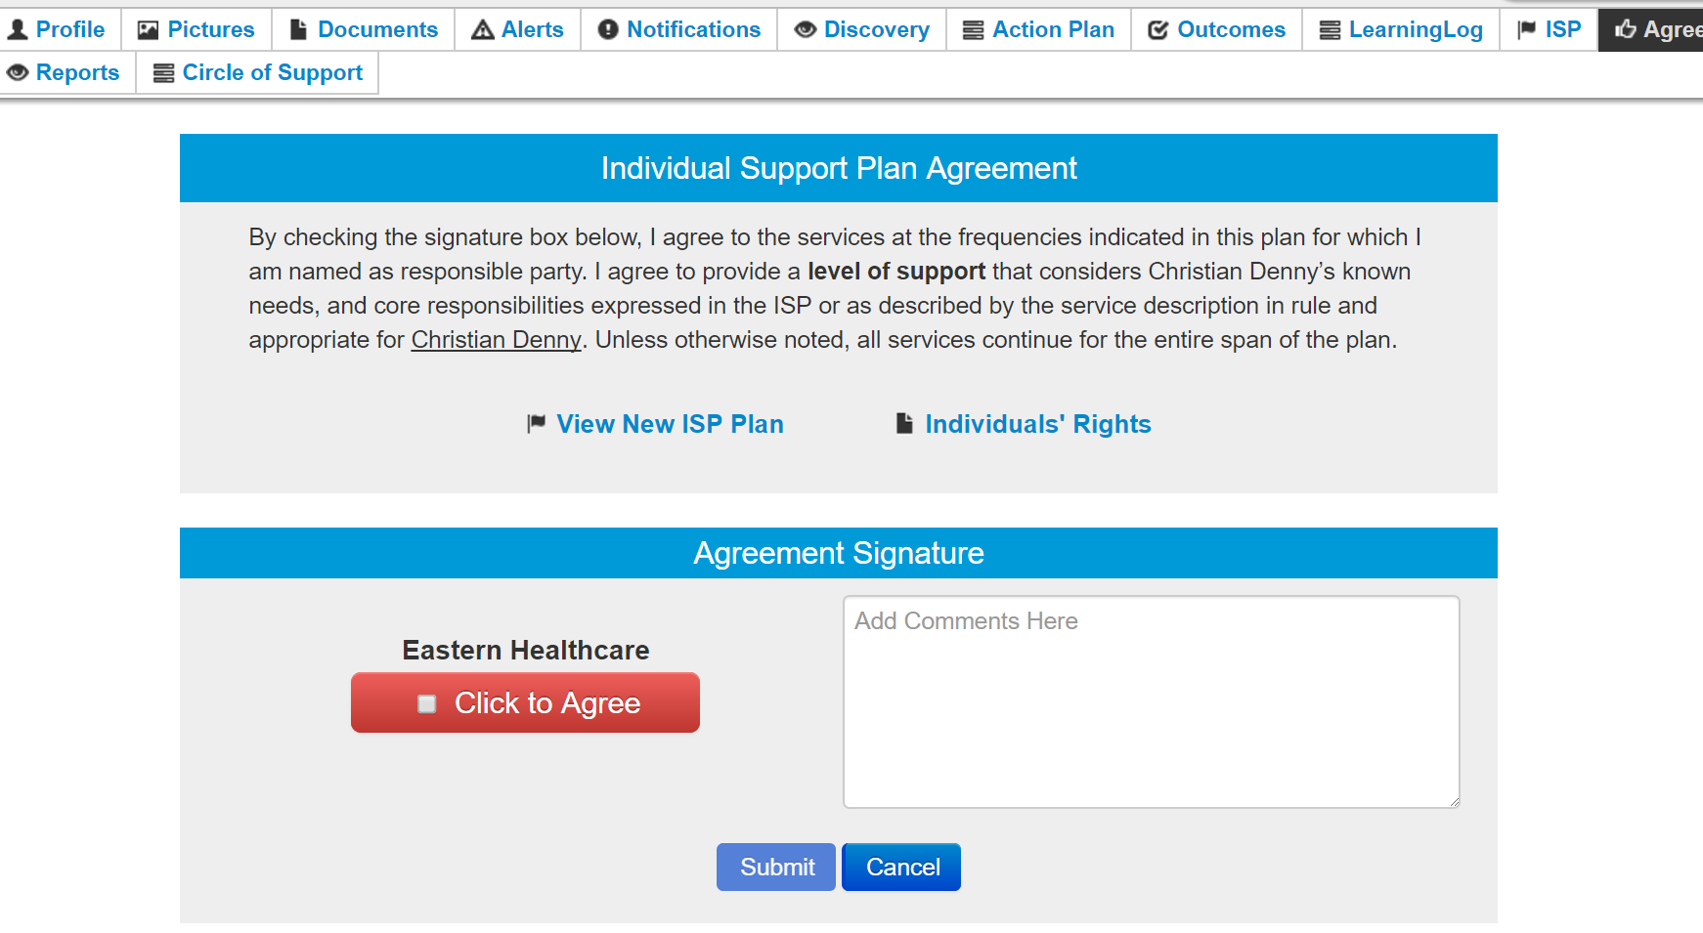

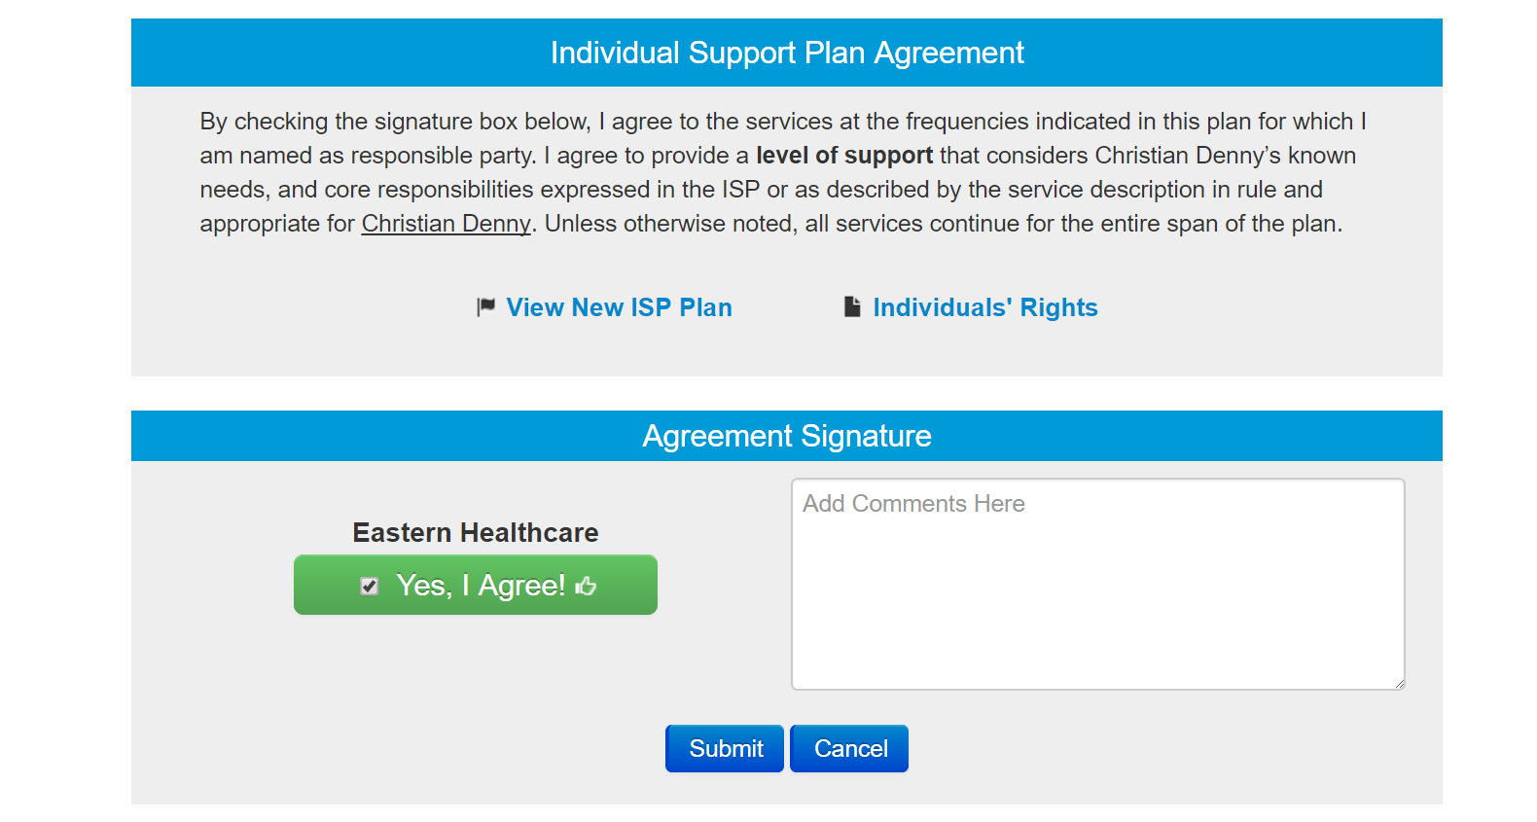

Notice it turned green. Click Submit to actually submit your agreement to the system.

You can now see where you agreed.

